

**Discipline**

**Queries**

***(3 versions)***

**CS5201**

Stage-2

**Sheikh Muhammed Tadeeb (AU19B1014)**

* **Queries Version-1:**
* **Queries:**

1. How shall a new user register to the application.
2. How shall a user recover his account if he forgets his password.
3. How shall we authenticate that user is valid or not.
4. How shall a user maintain entry of goods that are purchased & sold by him.
5. How shall a user review the record of goods he/she has purchased or sold.

* **Query Description:**
* The places where we require user input must be attached with “insert” command in database.
* The places where we need authentication must be attached with “Select” command along with “where” clause which matches the specified conditions.
* **SQL queries:**

1. Insert into USER values (user_id, ‘username’, ‘password’, ‘key’);

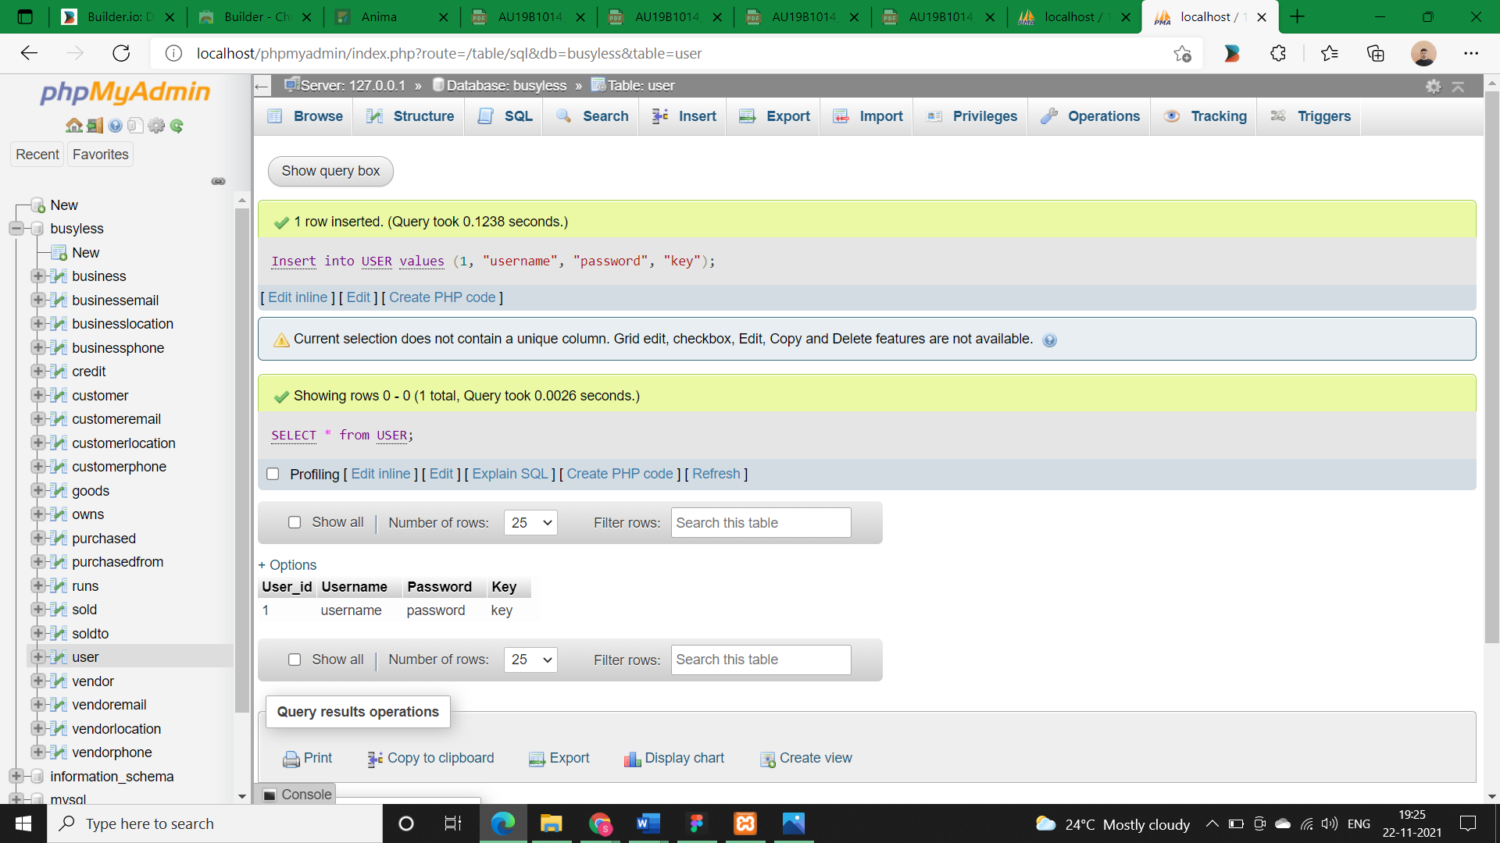 **Output:**

1. Select user_id from USER where username = ‘enteredValue’ AND password = ‘enteredValue’;

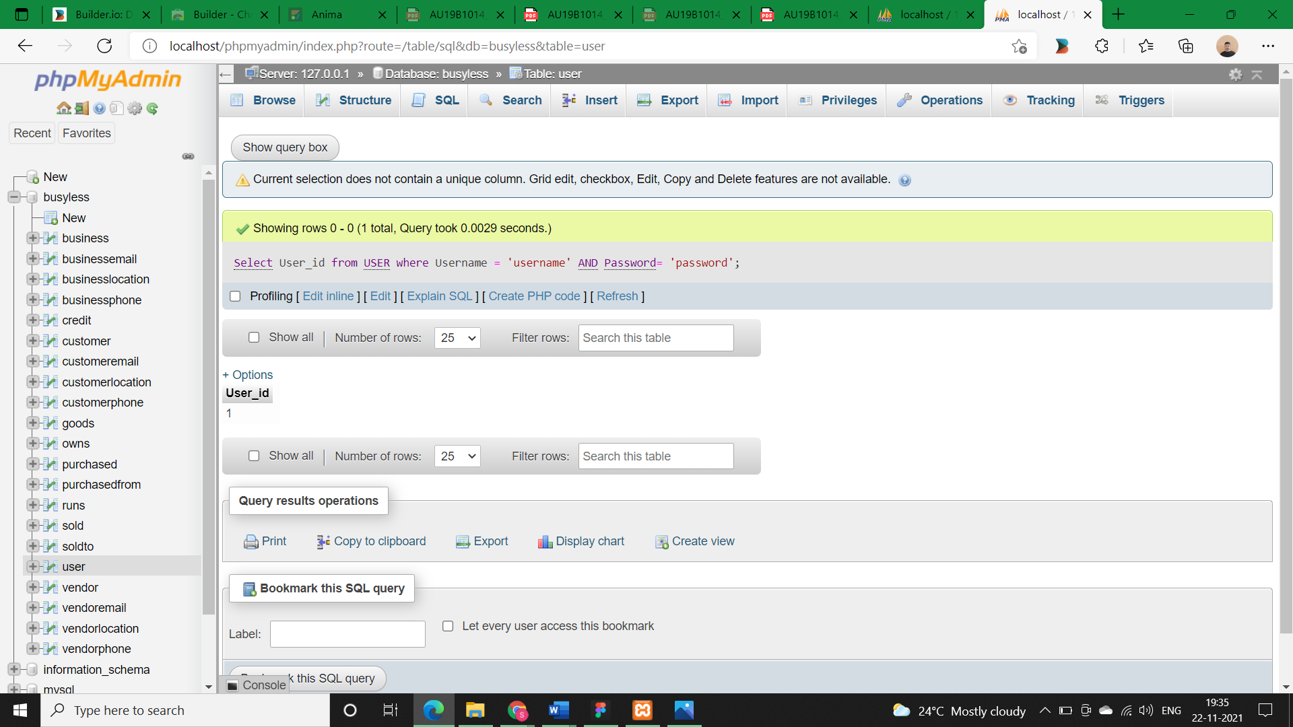**Output:**

1. Select user_id from USER where Reckey = ‘enteredKey’;

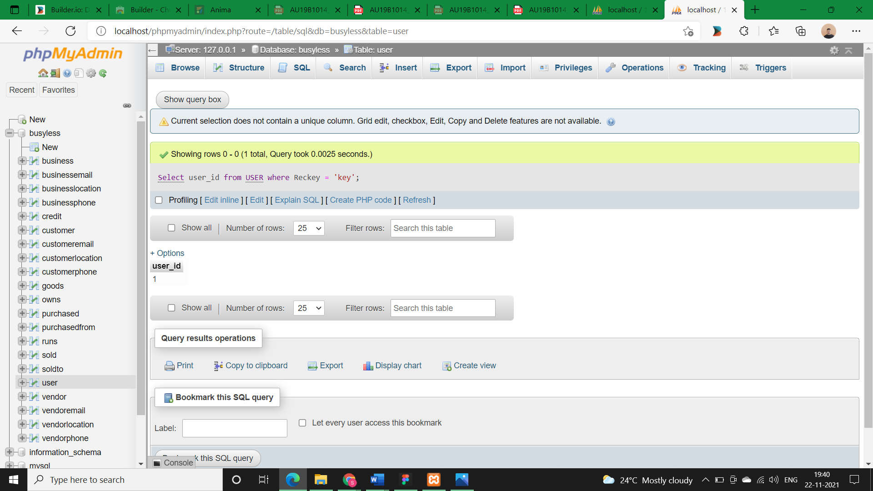**Output:**

1. Insert into GOODS values (goods_id, ‘goods_name’, ‘goods_type’);

**Output:**

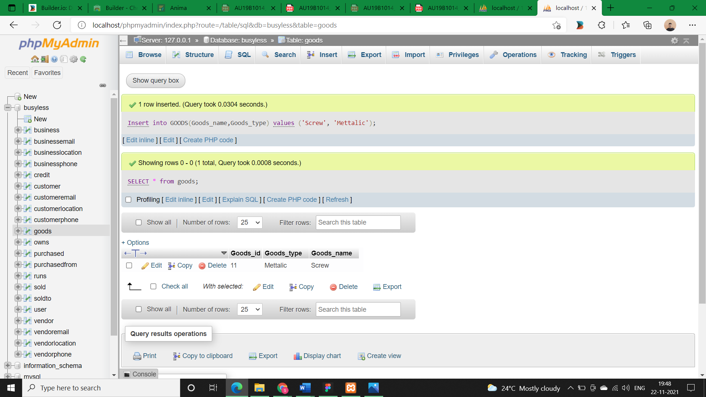

1. Insert into PURCHASED (Goods_id, P_qty, P_date, P_time, P_cost) values (goods_id, P_qty, ‘P_date’, ‘P_time’, P_cost);

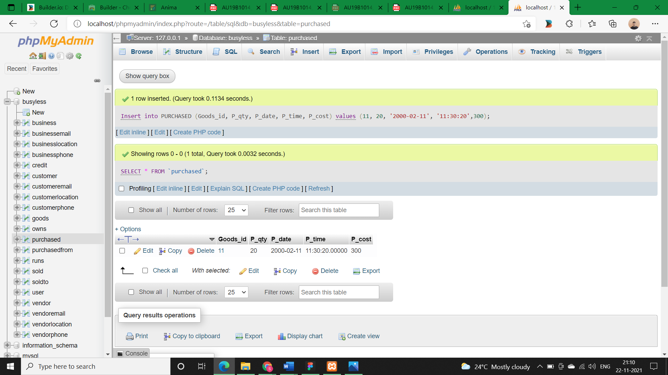**Output:**

1. Insert into SOLD (Goods_id, S_qty, S_date, S_time, S_cost) values (goods_id, S_qty, ‘S_date’, ‘S_time’, S_cost);

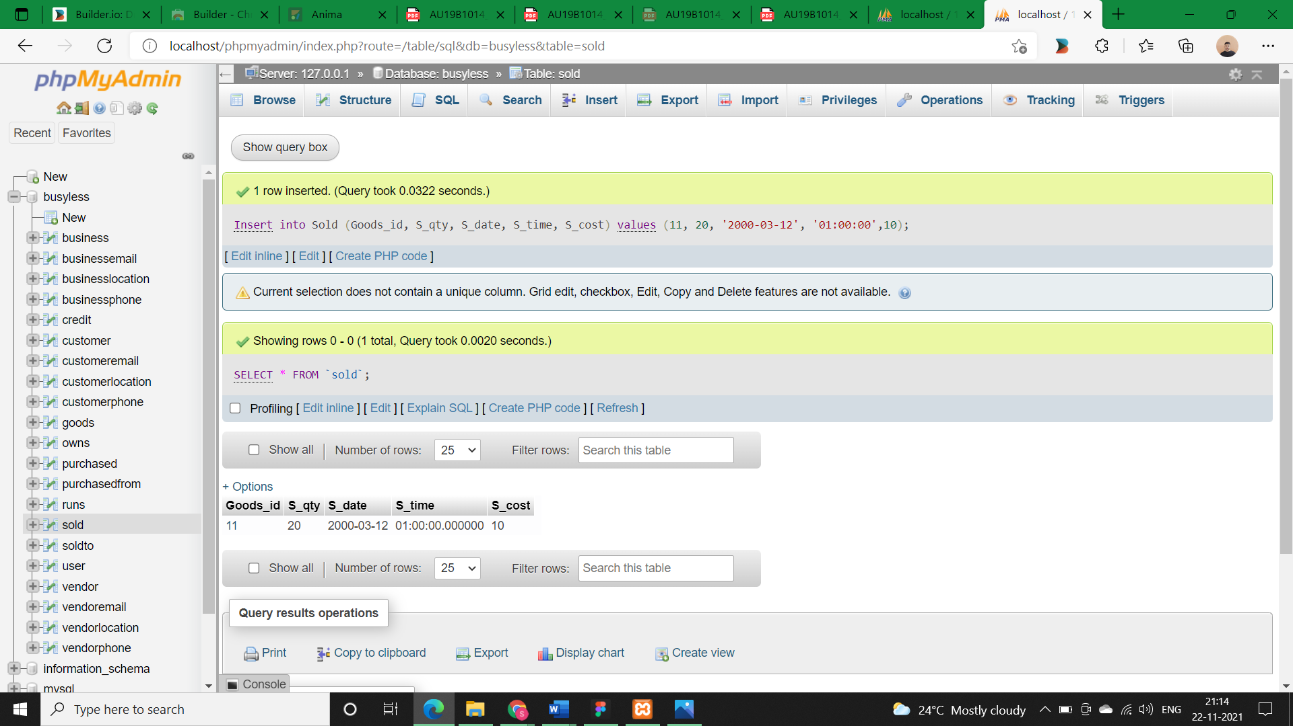**Output:**

1. Select * from PURCHASED Inner join goods ON goods.goods_id = purchased.goods_id where goods_name = ‘enteredName’;

**Output:**

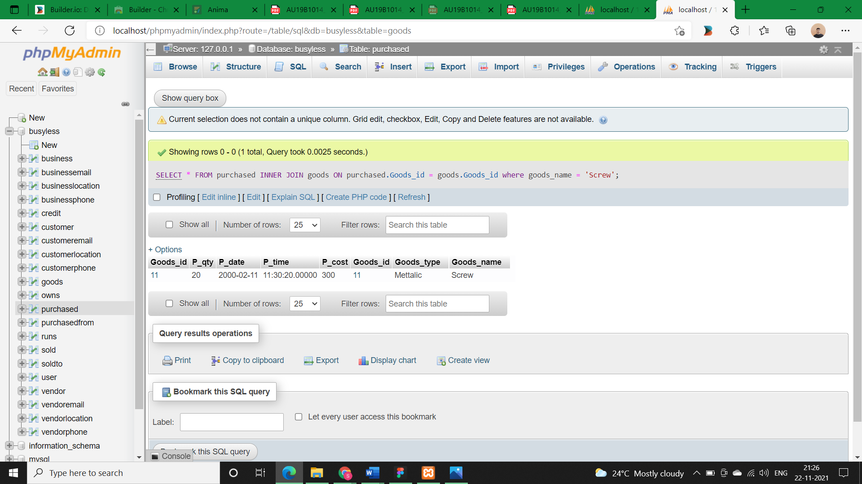

1. Select * from SOLD Inner join goods ON goods.goods_id = sold.goods_id where goods_name = ‘enteredName’;

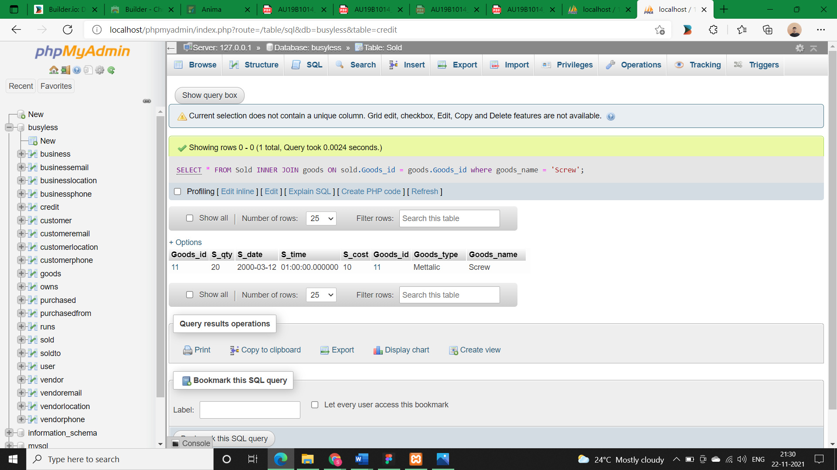**Output:**

* **Queries Version-2:**
* **Queries:**

1. How shall a user detect the credit he/she have on his/her business.
2. How shall a user detect the credit duration on his/her business.
3. How shall a user detect the credit he/she have on his/her customers.
4. How shall a user detect the credit duration on his/her customers.

* **Query Description:**
* A SQL Join statement is used to combine data or rows from two or more tables based on a common field between them. Different types of Joins are:

1. INNER JOIN: The “inner join” keyword selects all rows from both the tables as long as the condition satisfies. This keyword will create the result-set by combining all rows from both the tables where the condition satisfies i.e. value of the common field will be same.
2. LEFT JOIN: This join returns all the rows of the table on the left side of the join and matching rows for the table on the right side of join. The rows for which there is no matching row on right side, the result-set will contain null. “LEFT JOIN” is also known as “LEFT OUTER JOIN”.
3. RIGHT JOIN:  Right join is similar to Left join. This join returns all the rows of the table on the right side of the join and matching rows for the table on the left side of join. The rows for which there is no matching row on left side, the result-set will contain null. RIGHT JOIN is also known as RIGHT OUTER JOIN.
4. FULL JOIN: Full join creates the result-set by combining result of both “left join and right join”. The result-set will contain all the rows from both the tables. The rows for which there is no matching, the result-set will contain NULL values.

* The places where we need get the data we must use “Select” command along with “where” clause which matches the specified conditions.
* **SQL queries:**

1. Select SUM (P. P_cost – C.Amount_payed) AS ‘CREDIT’ from PURCHASED AS P INNER JOIN CREDIT AS C ON P.Goods_id = C.Goods_id where Business_name = ‘enteredName’;

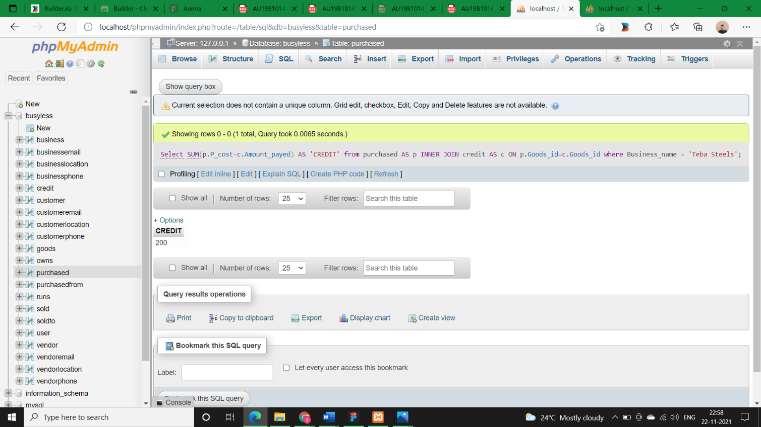**Output:**

1. Select CURDATE()-p.P_date AS 'Duration/goods limit in days‘ , CURTIME()-p.P_time AS ‘Duration/goods limit in hours’ from PURCHASED AS p INNER JOIN CREDIT AS c ON p.Goods_id = c.Goods_id where (Select Goods_id from goods where goods_name = 'enteredName');

**Output:**

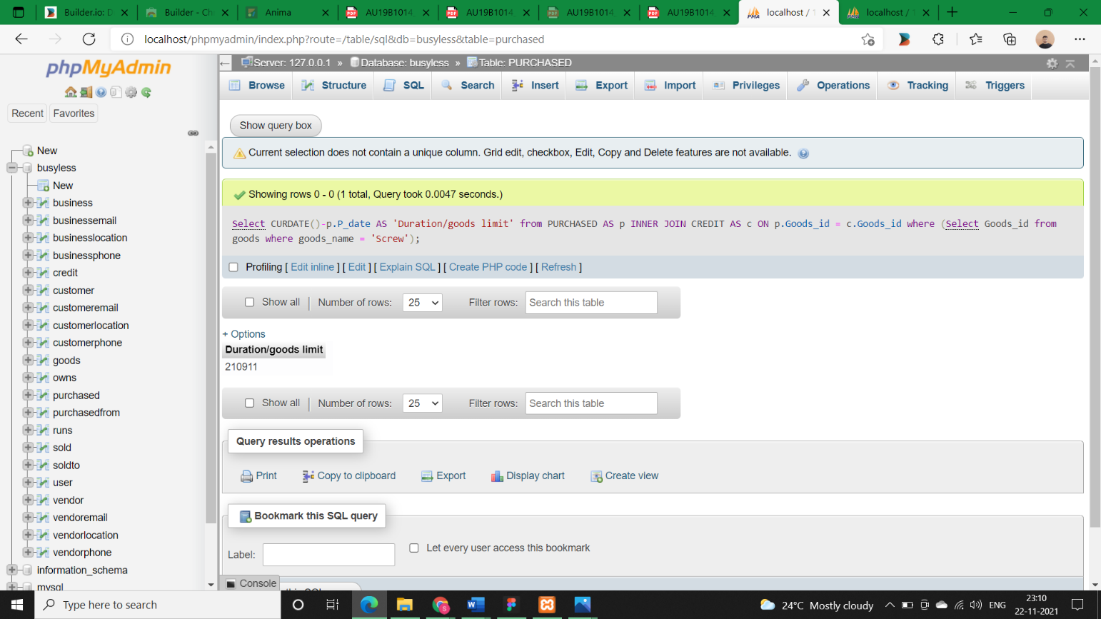

1. Select SUM(s.S_cost - c.Customer_Amount_payed) AS ‘Credit on Customer’ from sold AS s INNER JOIN credit as c ON s.Goods_id = c.Goods_id where (Select C_id from customer where F_name = ‘enteredName’);

**Output:**

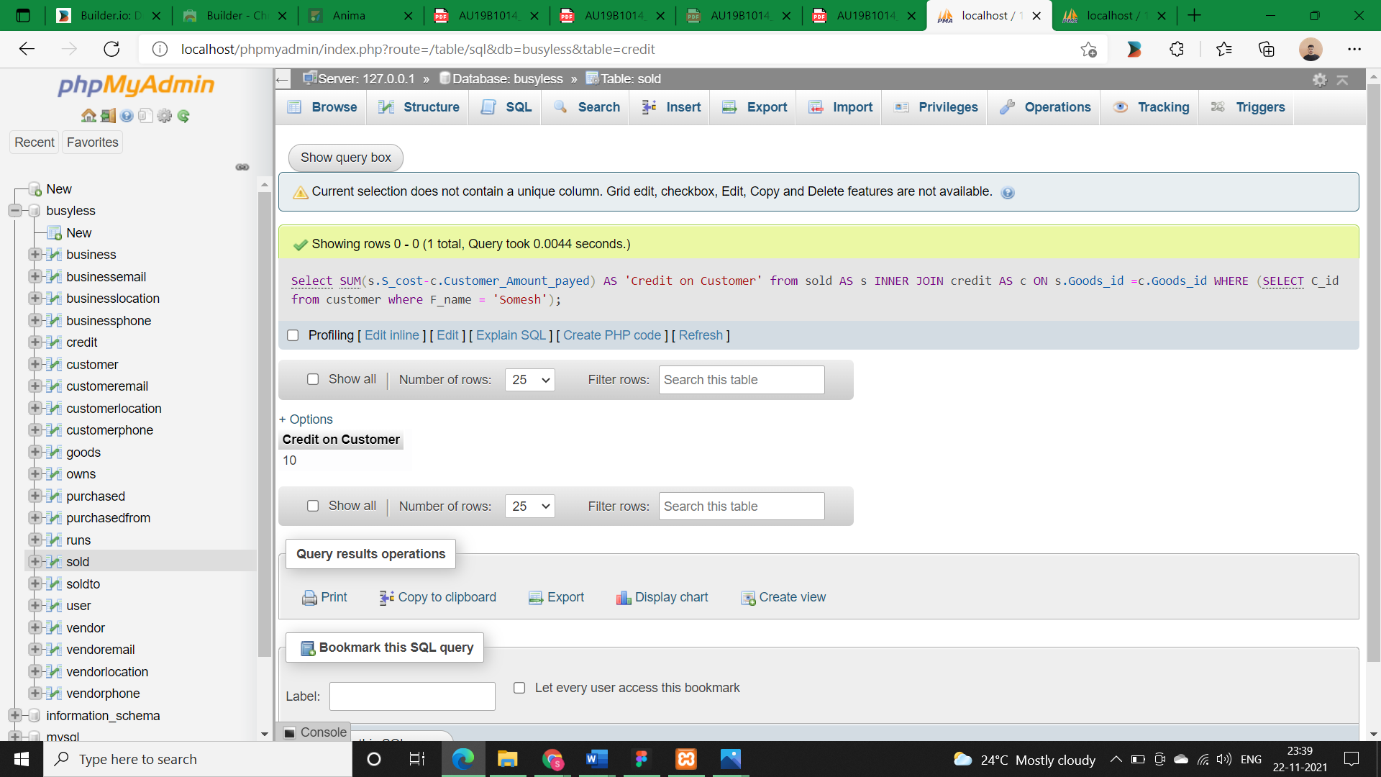

1. SELECT Curdate()-s.S_date AS 'Duaration/Credit limit in days', CURTIME()-s.S_time AS 'Duaration/Credit limit in Hours ‘ from sold AS s INNER JOIN credit  AS c ON s.Goods_id=c.Goods_id where (Select C_id from customer where F_name= 'Somesh');

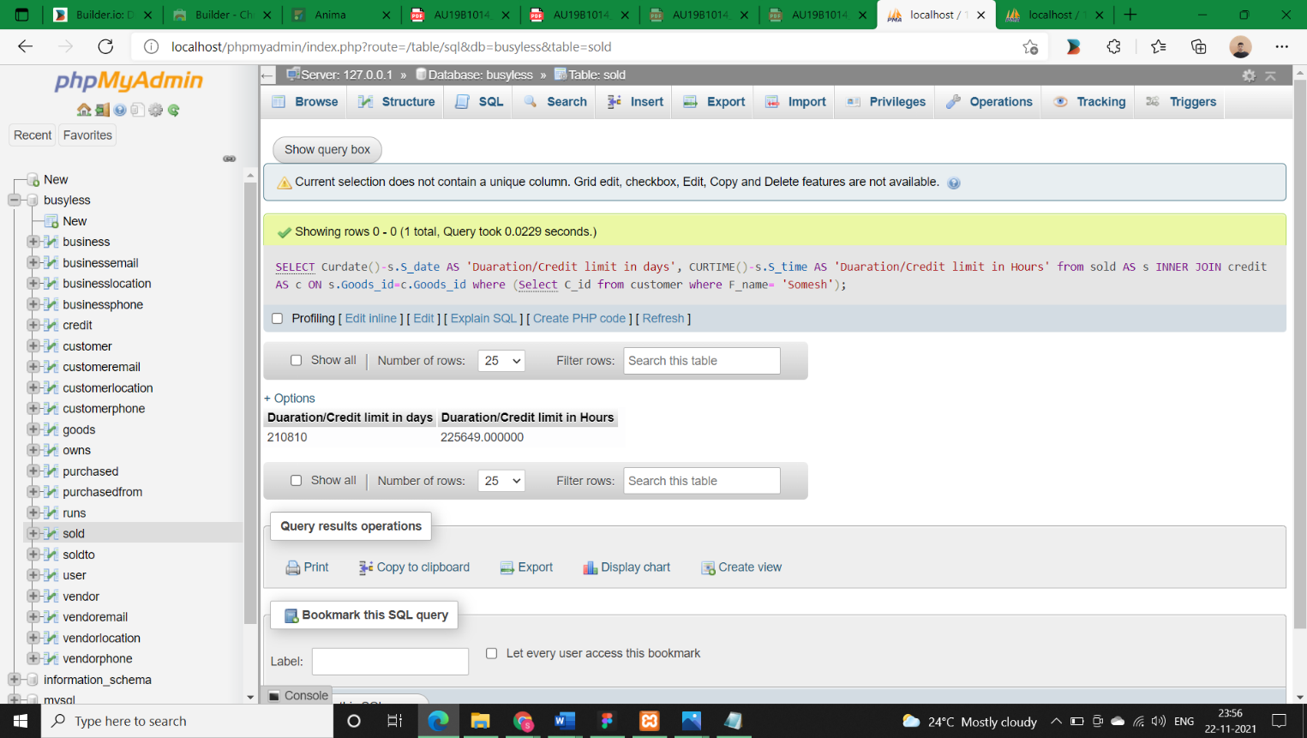**Output:**

* **Queries Version-3:**
* **Queries:**

1. How shall a user detect the profit he/she made through his/her business.
2. How shall a user detect the static duration of product in his/her shop.

* **Query Description:**
* A SQL Join statement is used to combine data or rows from two or more tables based on a common field between them. ***I have used joins on 3 tables here***:
* **SQL queries:**

1. SELECT g.Goods_type, g.Goods_name, p.P_cost AS 'Purchased Cost',s.S_cost AS 'Sold Cost', p.P_cost-s.S_cost AS 'Profit' from purchased AS p INNER JOIN sold AS s ON p.Goods_id = s.Goods_id INNER JOIN goods AS g ON g.Goods_id = s.Goods_id;

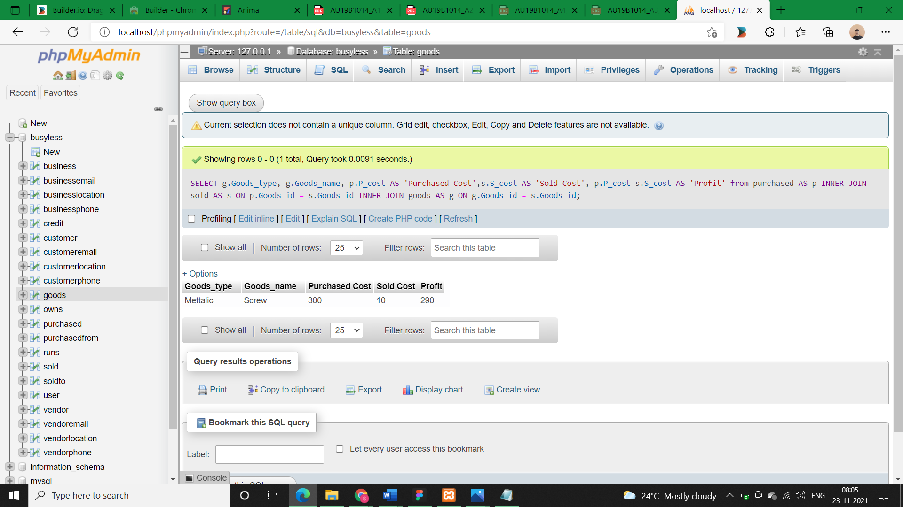**Output:**

1. SELECT g.Goods_type, g.Goods_name, p.P_date AS 'Purchased Date', s.S_date AS 'Sold Date', p.P_date-s.S_date AS 'Static limit (days)' , s.S_date-p.P_date AS ‘Static limit (Hrs)’ from purchased AS p INNER JOIN sold AS s ON p.Goods_id = s.Goods_id INNER JOIN goods AS g ON g.Goods_id = s.Goods_id;

